OG Web.site
Unit 3 NumPy ndarray Evidence Pack
Learner: Rob Johnston
Evidence task: Use NumPy to create and save an ndarray, with explanation in Jupyter Notebook comments or markdown cells.

Evidence Summary
This evidence pack contains an annotated Jupyter Notebook, saved ndarray files, VLE URLs, and four annotated screenshots showing the create, inspect, save and load-back process.

01 create ndarray with numpy
NumPy import and ndarray creation.
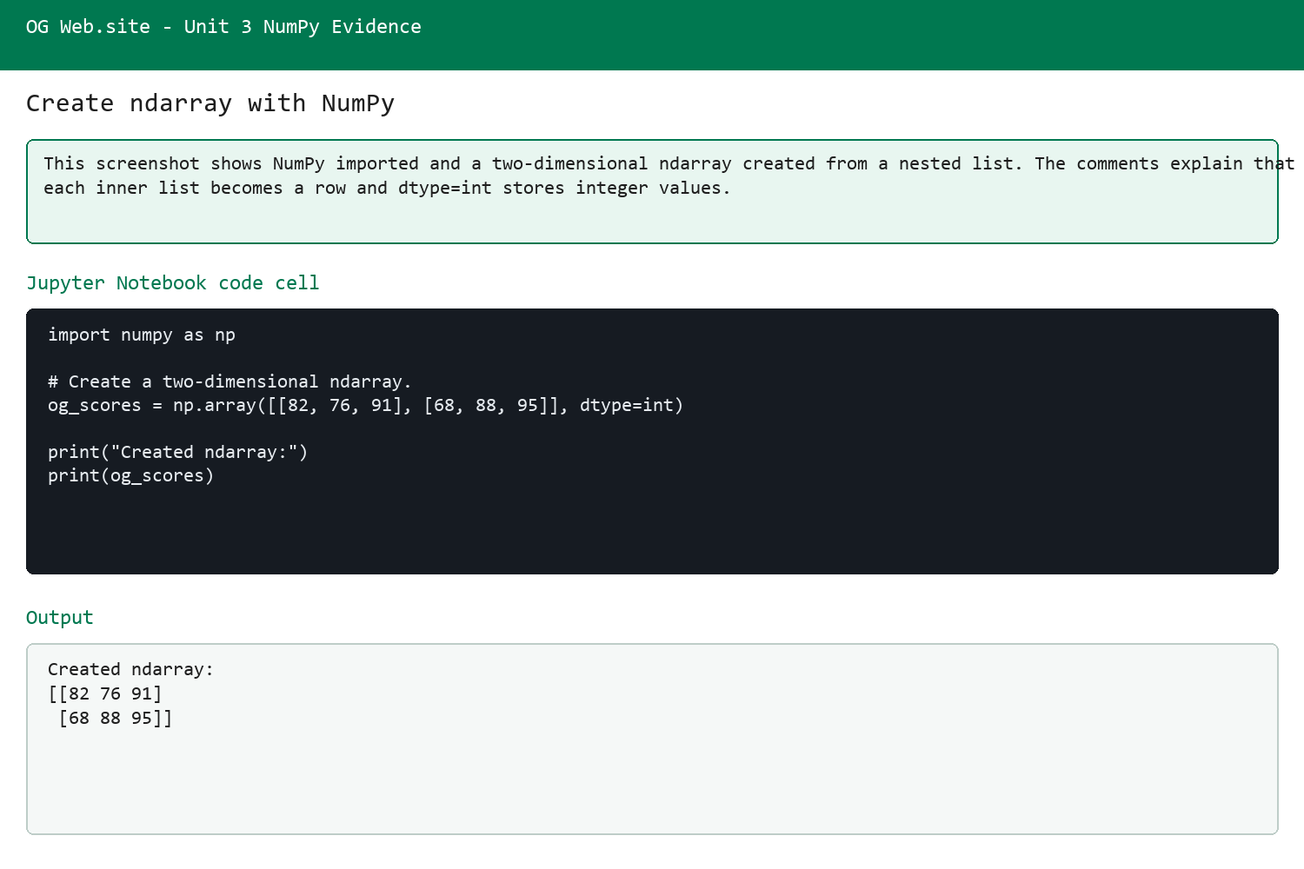

02 check ndarray properties
Array properties showing shape, dimensions, size and data type.
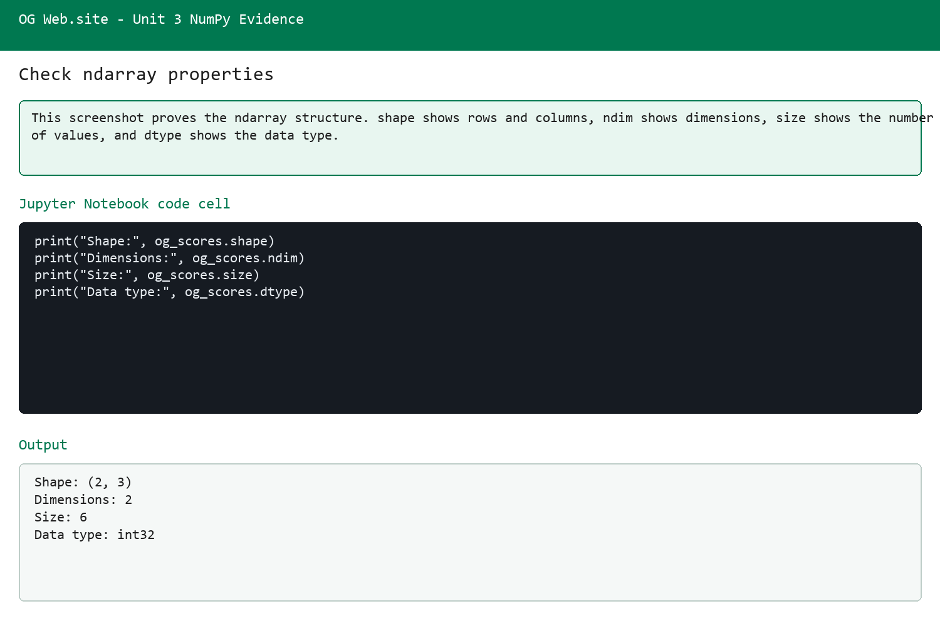

03 save ndarray files
Saving the ndarray as .txt, .csv and .npy files.
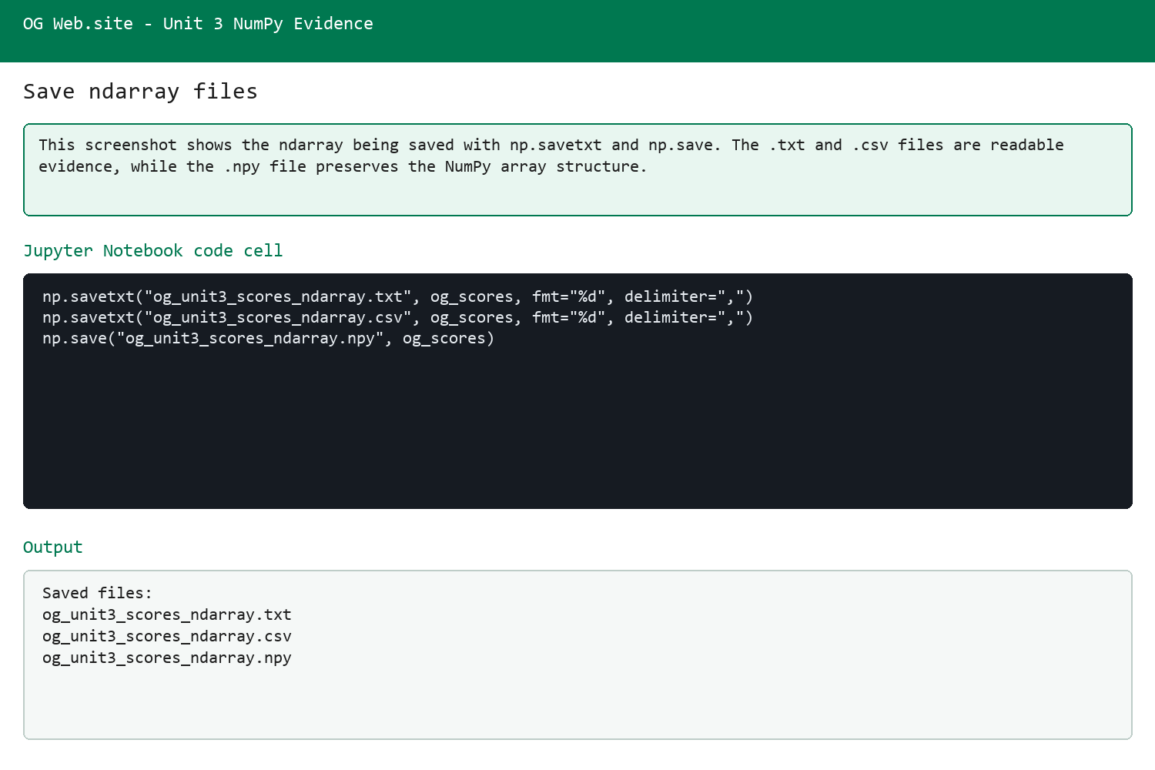

04 load saved ndarray files
Loading the saved files back to prove the save worked.
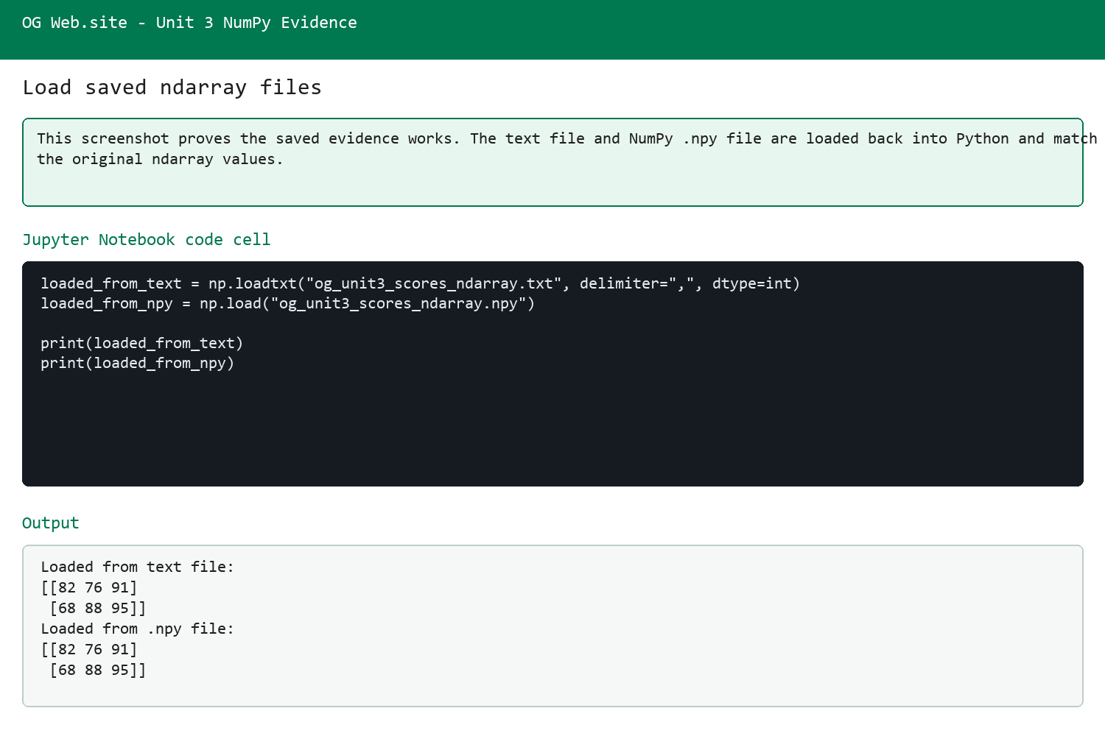

URLs
https://github.com/OG-Website/L3-Certificate-in-AI-Programming-with-Python/blob/main/unit-3/og-website-numpy-evidence-pack/02%20Jupyter%20Notebook/OG%20Web.site%20Unit%203%20NumPy%20ndarray%20Evidence.ipynb
https://github.com/OG-Website/L3-Certificate-in-AI-Programming-with-Python/tree/main/unit-3/og-website-numpy-evidence-pack

